LEARNING Guide
for
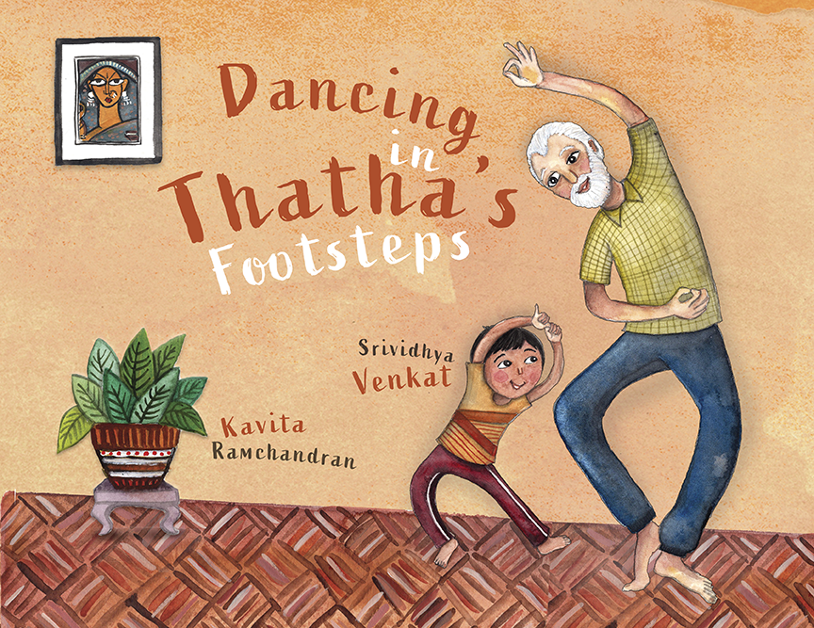
Age Range: 4-8 years
Grade level: 1-5
Themes: gender stereotyping, bullying, diversity, following your heart, family love
PUBLISHER: Yali Books
SYNOPSIS: On Sundays, Varun has his karate lesson, and his sister Varsha heads to dance school with their grandfather. One weekend, Varun reluctantly accompanies his sister to her lesson. Bored of waiting, he peeks into the classroom, and almost immediately, he is fascinated by the rhythm and grace of bharatanatyam, a dance from India that Varsha is learning to perfect. Varun tries a few moves at home in secret because…well, boys don’t dance, do they? His grandfather is not so sure. Will Thatha be able to convince Varun to dance in his footsteps?
A heartwarming picture book about an intergenerational Indian-American family discovering a shared love for bharatanatyam, an ancient classical dance form that continues to fascinate young dancers across the globe.
SRIVIDHYA VENKAT, Author
Srividhya Venkat is a former early childhood educator and storyteller who has been published in India where she was born and raised. DANCING IN THATHA’S FOOTSTEPS is inspired by her love for Indian classical dance and a desire to encourage young readers to ‘dance’ to their own tunes and have fun.

Her other picture books include Pickle Mania, Lunch-Friends, and The Clever Tailor, a 2020 South Asia Book Award (SABA) Highly Commended Book that also won the 2019 SCBWI Crystal Kite Award. With DANCING IN THATHA’S FOOTSTEPS, Srividhya makes her U.S. debut.
www.srividhyavenkat.com

KAVITA RAMCHANDRAN, Illustrator

Kavita Ramchandran is a professional graphic designer and self-taught illustrator with more than 14 years’ experience in the children's educational and entertainment spaces. She has art directed the award-winning children’s literary magazine - Kahani, (a showcase of South Asian culture), designed text books for Scholastic, McGraw Hill, Harcourt, and Curriculum Associates, illustrated award-winning apps for kids and has worked with Nick Jr., and Sesame Street Productions. In 2004 she created a pre-school property for Nick Jr. (Nickelodeon) based on her original character Maya, and developed it into animated shorts for their 'My World' cultural series.
She made her debut as a picture book illustrator in June 2021 with Dancing in Thatha’s Footsteps, Yali Books.

Originally from Bombay, she was born again in New York City, when she moved to pursue an MFA in Design from the School of Visual Arts. Growing up, she’s always loved children's books, (devouring a book a day), but never quite knew it could be ‘real job’. She lives in NYC with her husband, their kids and Chewbacca, the dog who (like Ferdinand) loves to smell flowers.
http://www.wemakebelieve.com
LEARNING Guide

READING COMPREHENSION
BEFORE reading Dancing in Thatha’s Footsteps, observe the cover.
- Who are the characters?
- What are they doing?
- Say the title aloud.
- Who do you think is “Thatha”?
- What do you think the story is about?
- Get familiar with the pronunciation of the word, bharatanatyam (bhuh-ruh-tha-NAA-tee-uhm)
AFTER reading Dancing in Thatha’s Footsteps, summarize the story.
- Where is Varun going in the beginning of the story?
- Why doesn’t he want to go inside the dance school?
- What makes him change his mind?
- How does he feel when he looks around the classroom?
- What does he want to do?
- Why don’t Varun’s sister, his friends and the girls at the dance school support him?
- Why does Thatha support him?
- How does the dance teacher, Ms. Kavita, feel about Varun dancing?
- Why does Varun quit dance lessons?
- What makes him change his mind in the end?

THINKING & DISCUSSION ACTIVITY
- Do you agree that “dance is not for boys”? Why or why not?
- Varun and his thatha share a common love of dance. What is the one thing you and a close family member share a common love for?
- Why is bharatanatyam so special to Varun? How do you think he feels about not being able to do something that he really loves?
- Can you think of a time/situation when you really wanted to do something, but could not? How did you feel, and how did you deal with the situation?
- Do you think the boys and girls, who were discouraging Varun, changed their minds in the end? Why or why not?
- What are some similarities between you and Varun? What are some differences between you and Varun?

WRITING ACTIVITY
- THE OTHER POINT OF VIEW - Explore the story of Dancing in Thatha’s Footsteps from the viewpoint of one (or more) of the other characters:
- Varsha (sister)
- The boys at karate class
- The girls at the dance school
- The teacher, Ms. Kavita
- Thatha

- WHAT’S YOUR DREAM?
- Do you have a dream in life? Write a few words about it.
- How can you fulfill their dream?

- DEALING WITH EMOTIONS
- List out the different emotions Varun experiences through the story.
- Think about the times you’ve felt each of those emotions.
- Write a few lines about one (or more) of them.
- It’s important to share your feelings with someone you trust. Varun confides in Thatha. If you experience emotions (like worry, sadness, frustration, anger), who would you confide in, and why?

RESEARCH ACTIVITIES
- Varun’s thatha used to live in India many years ago. That’s where Varun’s parents came from.
- Look closely at a map or a globe. Find where the city/state you live in. Then find India. See how far it is from your city/state.
- Find a few interesting facts about India, relating to: (any or all)
- Climate
- People
- Food
- Festivals
- History
- Dances
- Famous places
- Famous people

- Gather photos related to any or all of the above for a show-and-tell.

- Dancing in Thatha’s Footsteps is about the Indian classical dance, bharatanatyam. Find out the names of the other classical dances of India.

- Varun’s family speaks Tamil, one of several hundred languages spoken in India.

- Find the Tamil words for some of the following English words: Father, Mother, Sister, Brother, Grandmother, Hello, Food, Fish, Cow, Cat, Dog, Crow, Vehicle, Sun, Moon.
- Prepare a set of flashcards with Tamil words (using the glossary in the book and those researched above). Then make another set with their meanings in English.
- Play a memory matching game!

GET TO KNOW A LOVED ONE
Varun didn’t know that his thatha used to be a dancer, until his grandfather tells him so. You might be surprised that you didn’t know certain things about your loved ones, such as hobbies and interests when they were young, what their life was like, and many other things. Here’s your chance to get to know someone close to you even better!
- Talk to your grandparent, or other member of your family.
- Where were they born? Where did they go to school?
- What is a special talent they had in their childhood? Do they still pursue it?
- What is a special memory they have from their childhood?
- Can they share photographs?

ART IS MAGIC
Art plays a significant role in enhancing the story being told by the words. In Dancing in Thatha’s Footsteps, the illustrator has created details that make every scene come alive.
- Look closely at the illustrations in the book and have a classroom discussion about the following:
- What are things that are familiar to you, or have seen before?
- What are things that are unfamiliar to you, or have never seen before?
- Discuss what the unfamiliar things could be.
- If there are things unknown to the entire classroom, find out more through a research exercise.

- Play an I-Spy game using the incredibly detailed illustrations in the book. Can you find the following?
- Page 4-5
- kebab stall
- rainbow flag
- bench
- brick building
- pedestrian crossing
- truck with ‘Black Lives Matter’
- biker
- taxi
- street signs
- mailbox
- churros stall
- dog
- Varsha’s dance-mate

- Page 8-9
- footrug with welcome message
- wooden block and striker
- ankle bells
- jasmine flowers

- Page 17
- wall hanging/painting
- potted plants
- conch shell
- a dancing statue
- flower vase

